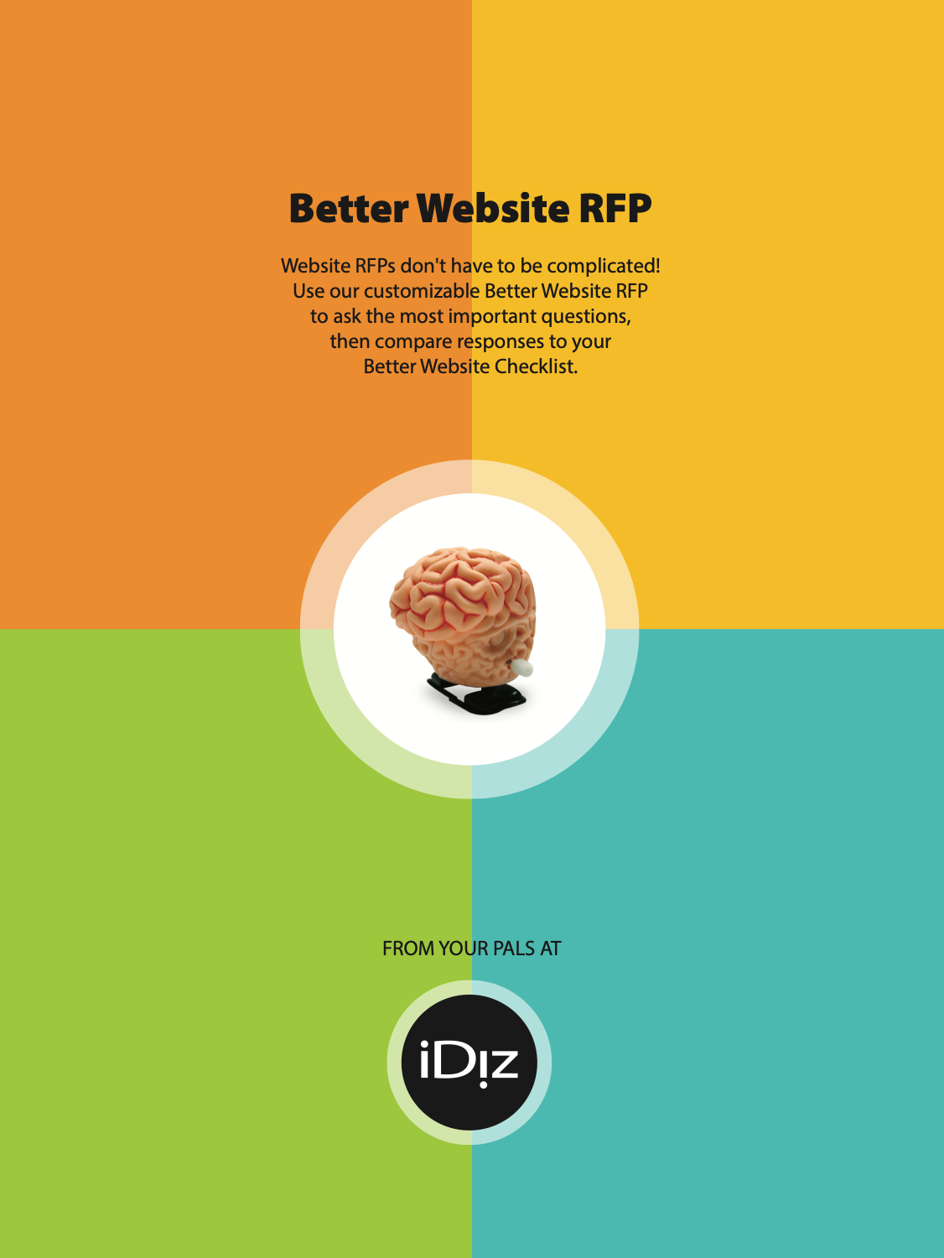

Better Website RFP
This is a free resource to help you think about and ask the right questions when you're deciding on a website vendor. It’s purpose is to help you remove the clutter from your RFP and focus on factors that will ensure a long and successful partnership. Feel free to copy, paste, slice-n-dice, and use what you like.
The truth is, lots of vendors (including iDiz Inc.) can build nice credit union websites. There are plenty of good ways to build a website and keep it up to date, reliable, and secure. We all have different approaches and experiences, with different benefits and compromises. These questions will help you sort out the answers that matter.

Not to brag, but...
We put this together because we’re pretty sure the iDiz, Inc. approach to building credit union websites is about the best around, and we’d like more credit union people to think along these lines when they’re thinking about their websites.
You can get further acquainted with our approach to credit union websites and accessibility with these pages and blog posts:
https://www.cuidiz.com/what-we-do/credit-union-websites/
https://www.cuidiz.com/what-we-do/accessibility-services/
https://www.cuidiz.com/tag/websites/
And when it’s time to take your website to the next level, please get in touch!
____________
These are the questions that are included in this RFP
along with a few pointers on how to get the website you’ve always wanted:
1. Describe your general approach to Design/Creative/UX. What’s your overall process for building a beautiful website that works intuitively for the user?
Don’t expect specifics about your website yet, but the answers should be unique, thought-provoking, and a good match for your culture, your growth goals, and your member service philosophy. How do they think through design, branding, interface, and online communication? This is an important part of figuring out what they’re going to be like to work with.
2. Describe the capabilities of your CMS:
This is more nuts and bolts. Does their Content Management System do everything you need it to do? Is it easy to use and fast? Are you going to need expensive add-ons to do what you need? What can the CMS do that’s way above and beyond your basic needs? Look for useful stuff, not crazy bells and whistles.
3. How do you handle integration with all third-party services? What’s the process for possible future changes that affect the website, such as a new online banking or core provider, a brand or logo update, adding third-party features such as live chat or marketing automation, etc.?
Credit union websites are living, breathing things. Evolution is natural and necessary; your website should evolve over time to work better for you and your members. How does this process work, and are they familiar with the sorts of things credit unions often need to change? What are the costs and timelines like? How do they design and build robust websites that can be changed easily? Are they happy to play nice with your transaction side vendors, like Online Banking, apps, P2P, chat, etc.?

4. Describe your approach to maintaining the security, reliability, and speed of our website. Discuss hosting arrangements, security, uptime, monitoring, and remediation. What are the responsibilities of everyone involved with the website? What will be our responsibilities for keeping the website safe? What if something horrible happens?
There will be some technobabble, but insist on answers and explanations you can understand. If there are specific past threats you’re worried about, feel free to ask -- the answers should indicate that they’re WAY ahead of you! That said, there’s usually not much point in asking about specific threats, certifications, or technologies, since the landscape changes incredibly quickly. Look for a high priority on security and reliability, and expertise with mission-critical websites.
5. How does training and tech support work? How are you able to help when we need an extra hand? What are typical costs?
This is fairly straightforward, but it does vary a lot. How will training, support and updates fit into your workflow and budget? How does communication work best, and how quickly can you expect a response? What are the expectations both ways?
6. What SEO & Optimization services do you provide?
Some website developers are just developers, some can offer one-stop-shopping for much broader expertise in digital marketing, content creation, optimization, etc. What’s going to be the best fit for you? Do they have expertise specific to credit unions?
7. Are you able to incorporate our existing CRM or marketing automation?
Or do you have one that you recommend?
Look for flexibility. Credit unions and where they are in their digital marketing journeys vary tremendously. If your CU has a solution in place that’s working well, can your website developers stir it into the mix, and make it work even better? If you’re not sure or just getting started, can they help you figure it out? Are you going to be locked in to anything, or is there room for future experimentation, growth, and change?
8. What additional capabilities and recommendations do you have?
Sky’s the limit! Look for credit union expertise, and familiarity with strategic challenges that credit unions will be facing over the next several years. How will they push your CU to the next level, and keep pushing?
9. Have you designed websites for other financial institutions? Have you worked with credit unions? If so, please describe and list referrals. What are a few challenges you’ve helped your clients handle?
Credit union and financial experience does make a difference; just as CUs are fundamentally different, CU websites are very different in some important and not always obvious ways.
10. Our website is the cornerstone of our marketing and branding. How can you help us leverage and coordinate our website, brand, and marketing investments?
“Plays nice with others” is a fundamental requirement. Make sure their highest-level values, priorities, philosophies and strategic thinking styles are compatible with yours. Look for a credit union passion, a drive to make the world a better place.
11. We’ll be spending a lot of time together, so it’s important for our teams to have compatible cultures and a high level of mutual trust. How would you describe your culture and team? Why do you think we’ll get along?
Are you cat people or dog people? Seriously… culture and personalities matter, and you’ll need to make sure you can work together, even if things get tough. Obviously, you’ll learn a lot about culture from the other answers, but it’s absolutely a very important factor, and well worth putting the cards on the table.
Downloaded from https://www.cuidiz.com/website-starter-kit/ and provided by your friends at iDiz.
If you have questions call us at 317.257.0000 or email contact@idizinc.com

Better Website RFP
Please answer the following questions when you create your proposal.

1. Describe your approach to Design/Creative/UX:

2. Describe the capabilities of your CMS:

3. How do you handle integration with all third-party services? What’s the process for possible future changes that affect the website, such as a new online banking or core provider, a brand or logo update, adding third-party features such as live chat or marketing automation, etc.?

4.Describe your hosting, including where the data center is located, backups and security measures:

5. How does training and tech support work? How are you able to help when we need an extra hand?

6. What SEO & Optimization services do you provide?

7. Are you able to incorporate our existing CRM or marketing automation? Or do you have one that you recommend?

8. What additional capabilities and recommendations do you have?

9. Have you designed websites for other financial institutions? Have you worked with credit unions? If so, please describe and list referrals.

10. Our website is the cornerstone of our marketing and branding. How can you help us leverage and coordinate our website, brand, and marketing investments?

11. We’ll be spending a lot of time together, so it’s important for our teams to have compatible cultures and a high level of mutual trust. How would you describe your team?

12. What other areas of expertise do you have to offer?

Downloaded from https://www.cuidiz.com/website-starter-kit/ and provided by your friends at iDiz.
If you have questions call us at 317.257.0000 or email contact@idizinc.com

