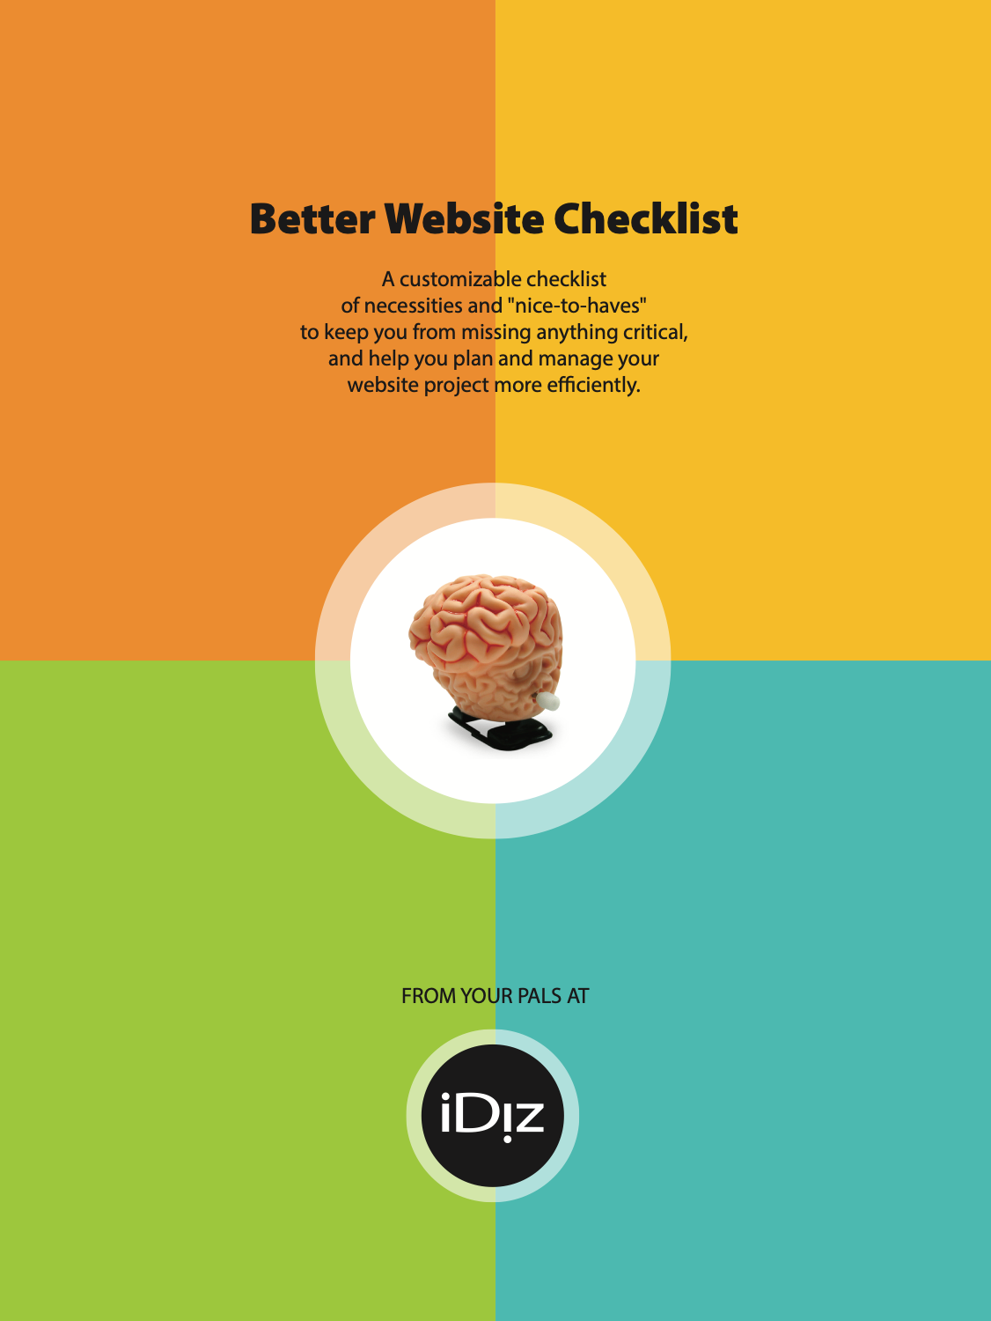
Better Website Checklist

Our new website must include:
1. Design/Creative/UX:
- Mobile-first, touch-friendly, responsive design that works well on all devices
- Accurately reflects CU brand; pushes our brand forward
- Clear, simplified interface
- ADA conformance/accessible at WCAG 2.0/2.1 AA standards
- Effective, easy internal search
- Thorough testing in a wide variety of devices/browsers
2. An established, well-supported CMS that is:
- Extensible and expandable (plug-ins, custom development, etc.)
- Not locked into or dependent on a specific vendor
- Easy and fast to use for all regular tasks, including:
  - Creating a new page
  - Updating navigation
  - Duplicating pages and content
  - Updating page content (images and text)
  - Updating rate sheets
  - Managing promotional content
  - Adding landing pages
  - SEO management/optimization
  - Creating blog posts
  - Creating video and image galleries
  - Managing integrations (social media, landing pages, tracking, forms, etc.)
  - Advanced content such as accordions, graphs/charts, embedded HTML
3. Easy integration with a variety of third-party services, such as:
- Online Banking
- Calculators
- Maps (Google Maps, locator service)
- Analytics with event tracking
- Loan and Membership Apps
- Surveys, feedback
- Social media/digital marketing
- Custom code
4. Security and Hosting that includes:
- Written, understandable security policies and processes
- Monitored for nefarious activity, uptime, speed, and software updates
- Hosted in a major, secured, fully staffed data center in the US
- Daily backups with fast recovery process
- Member data secured and separated from website data
(continued)

5. Support when we need it:
- Initial staff training at launch with additional training when needed
- Ability to handle additional changes as needed at our direction
- Urgent/emergency/after hours support
- Coverage and continuity when CU staff are out of the office
- Maintaining Accessibility

Additional capabilities desired:
6. SEO and Optimization Services:
  - SEO strategy/planning services
  - Content creation (research, writing) services
  - Existing content editing and optimization
  - Tools in CMS for assessing and improving content
7. CRM/Marketing Automation:
- Able to integrate with current CRM solution or recommend better solution
- Personalization based on user behavior/characteristics
- A/B testing and tracking
- Custom landing pages and microsites
8. Additional Site Capabilities:
- Blog
- Chat/chatbots
- Comments and ratings
- Intranet
- Private section for Board Resources
- Multiple languages
- ____________________________________________________________
____________________________________________________________
____________________________________________________________

Important factors for evaluating vendors:
9. What kind of company do we want to work with?
  - Experience designing website for financial institutions, particularly credit unions
  - Understanding of website as cornerstone of marketing and branding
  - Compatible culture and mutual trust (someone we can work with)
  - Additional areas of expertise that we might be able to draw upon

Downloaded from https://www.cuidiz.com/website-starter-kit/ and provided by your friends at iDiz.
If you have questions call us at 317.257.0000 or email contact@idizinc.com

